# How To: Conditions Files

Conditions files are simply repositories for the stimuli that you want to present on screen. However, they are not limited to just stimuli presentation, you can change things such as the orientation of a stimulus, the colour of text, the size of text, the position of components on the screen and specify a correct or incorrect response.

## Why do we use them?

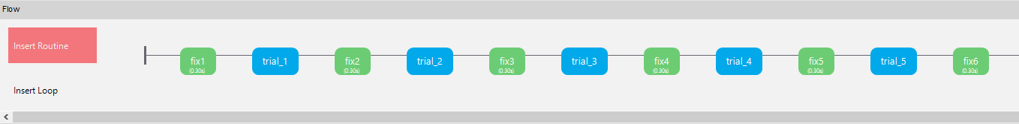Imagine an experiment where you want to present 80 trials to a participant. You could create a routine for each single trial, so your Flow would have at least 1 routine per trial, plus instructions, keyboard responses, fixations, inter-stimulus intervals and a debrief.

Figure

This create an exceedingly long experiment flow, see the image above (and that only shows five trials and the corresponding fixations). Each single trial would need to have the exact stimuli selected in the properties for the components, and changes would need to be made for each single response etc.

The resulting dataset would also be extensive, as that would also have the corresponding 80 columns, plus a .corr, .rt, .started .stopped for each of those 800 trials and their corresponding routines. This makes the dataset difficult to interpret and unwieldy.

Figure

So instead, when we know what one trial looks like, and each trial is to be presented in the same way, just with different stimuli on each iteration, then it makes sense to store that information somewhere. In the case of PsychoPy, this is in the conditions file (conds file). Once we have stored our conds file, we use a loop to surround a single trial, and then it will repeat that trial until all stimuli have been used.

## What can I put in a conds file?

Conditions files can handle information for Text components (type in the text you want to present), Sounds and Image components (type in the file path of the sound/image you want to present), numerical information such as orientation of a stimulus (in degrees), durations (in milliseconds), font size, and information about colour, etc. You can also include information useful for data analysis, such as block (e.g. practice block, trials block, conditions that you have manipulated).

## Example:

In this example we have a Sustained Attention to Response Task. In this task single digits between 1-9 are shown on the screen with a font size that also changes on each trial iteration. The participant is instructed to withhold a response when they see the number three. So, for every other digit they must press the space bar. They will be presented with 40 “go” trials, and 5 “noGo” trials.

+

digit

interstimulus interval

Figure

Each of the boxes in Figure 3 trial visualisation is a single routine. You would apply a polygon for the fixation cross, digits would be presented with a text component and the trial would also need a keyboard response component. You can use a blank text file for the inter stimulus interval. By now you should understand how to add routines and components. Your PsychoPy Builder flow would look something like this (Figure 4)

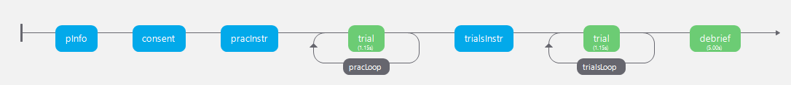

Figure

Remember your Loop is the place to attach your conditions file (Figure 5).

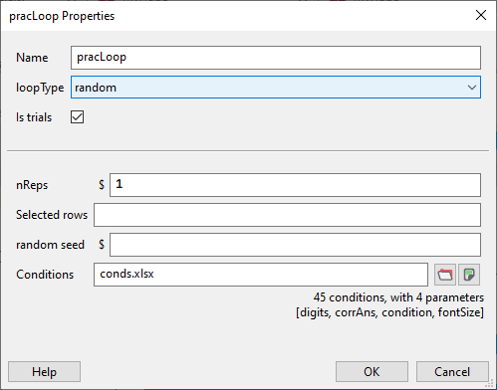

Figure

In the conditions file we have named the stimulus presentation column “digits”, we need to specify a correct response, so the next column is named corrAns.

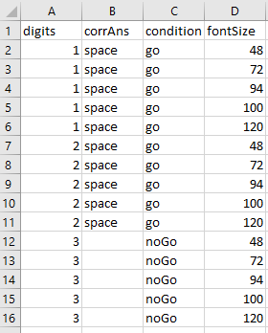

Figure

For data analysis purposes we need to know which condition the stimulus being presented relates to (condition) and we have two conditions here “go” where the participant would press the space bar, and “noGo” where they should withhold the response (left blank).

We also want to change the size of the font on each iteration so there is a column called fontSize.

The final piece of the puzzle is to edit the component properties to “reference” the conditions file. To do this we use the dollar sign $. For example, in the Text component called stimPres, we want to pick up a random digit from Column A in the conds file (Figure 6). This is named digits, so in the Text component properties window, we would type $Text, and select set to every repeat (Figure 7). Using the $ sign tells PsychoPy Builder that in order to present the stimulus on screen it needs to look into the conds file and randomly select a row to present for a response.

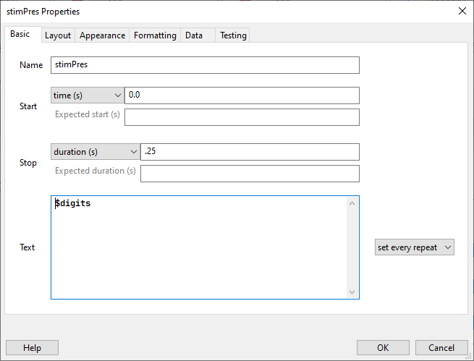

Figure

PsychoPy automatically creates a data file as soon as the program starts to run, and the information from the conditions file is repeated in the data file, followed by the stimulus presented, the time the component started, the reaction time, and the accuracy if specified, along with any demographic data you asked for at the start of the experiment.